 |   Bat Detector Kit Instructions

Date: | 06/08/2020 | Version: | 5.0 | By: | Matt Little

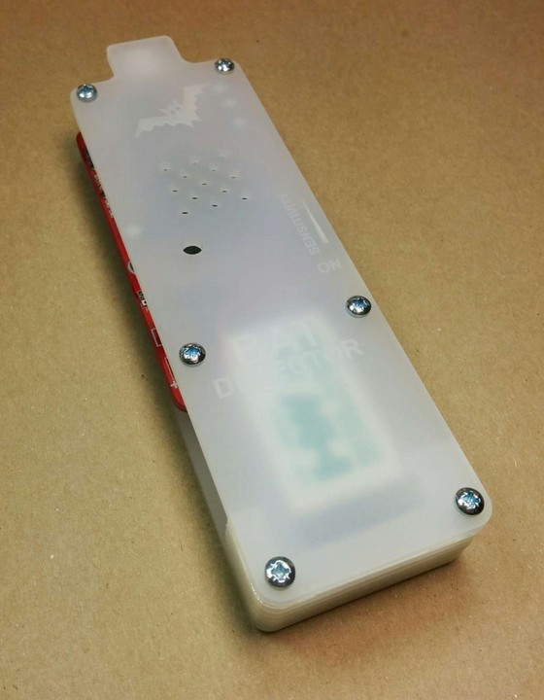 | Build your own Bat Detector!  Bats use ultra-sonic pulses to navigate and to detect prey. These pulses are very high pitch (around 5 times the maximum frequency humans can hear).  This electronic circuit converts the high pitched sounds produced by bats to a human-audible level.  It has a sensitivity control to adjust for different conditions.  It can also be used to listen to other high frequencies such as peeling sticky tape, compact fluorescent lights and power supplies.  This kit, although easy to build, requires quite a lot of soldering so will take in the region of 2-3 hours.
Parts included:
 |  |  | 14 x Resistors |  |  |  |  | PP3 battery clip
 | 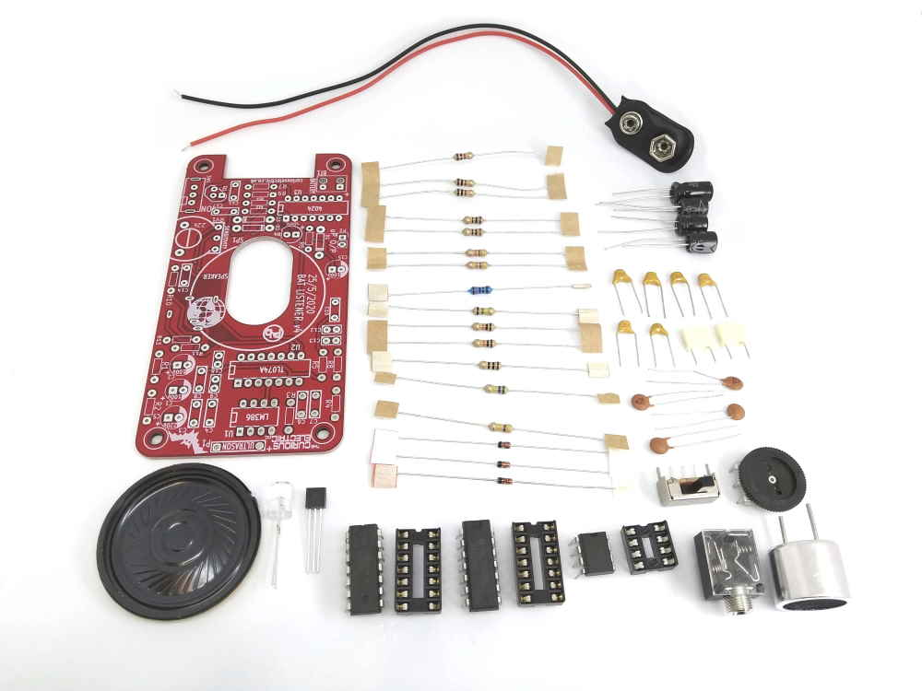 |  |  |  |  |  |  | PP3 battery clip
PCB |  |  |  |  |  |  |  | 17 x Capacitors
2 x 1N4148
Diodes
5.1 V Zener |  |  |  |  |  |  |  | Potentiometer
 |  |  |  |  |  |  |  | Switch
Speaker
 | LED | Transistor |  | 3 x IC holders | 3 x ICs | 3.5mm Jack Socket |  | Ultrasonic receiver
Enclosure Parts:
 | 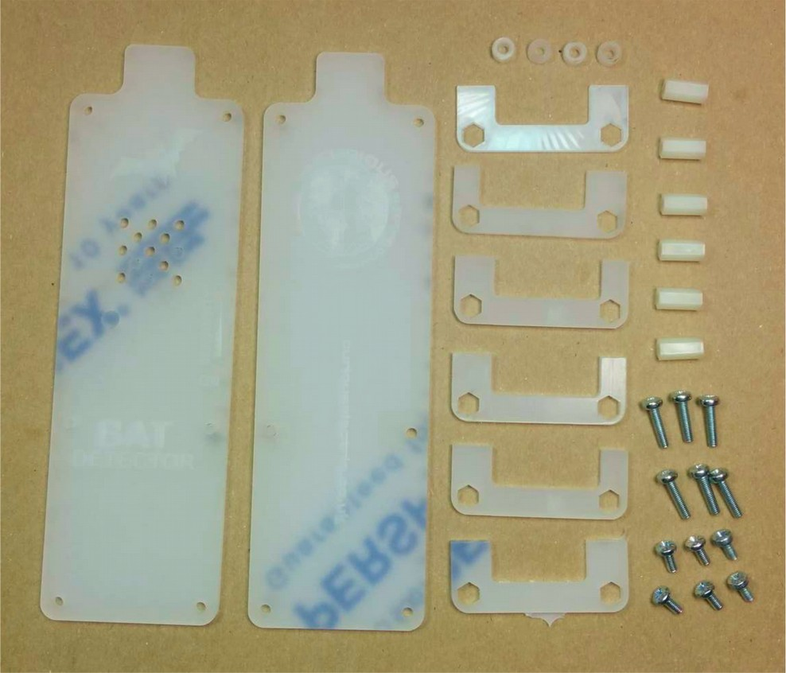
Front |  | 4 x spacers
Back
2mm end  (marked ‘6’) |  | 6 x M3 Hex  Spacers 12mm long
5 x 3mm thick spacers  (marked ‘1’-’5’) |  | 8 x M3 12mm  machine screws
 |  | 4 x M3 6mm machine screws

Parts list:
Item | Ref | Item | Ref
PP3 Battery Clip | BT1 | 47k Resistor | R1, R2
100uf Capacitor | C1, C2, C15 | 10 ohm Resistor | R3
220nf Capacitor | C3 | 1.3k Resistor | R4
47nf Capacitor | C4, C6 | 150k Resistor | R5
220uf Capacitor | C5 | 10k Resistor | R6, R12
2.2nf Capacitor | C7 | 1k Resistor | R7, R8, R14
1.5nf Capacitor | C8 | 470k Resistor | R9
100pf Capacitor | C9, C16 | 560k Resistor | R10
1nf Capacitor | C10 | 100 ohm Resistor | R11, R13
33nf Capacitor | C11, C17 | 20k Potentiometer | RV1
470pf Capacitor | C12, C13 | 40mm Loudspeaker | SP1
100nf Capacitor | C14 | Switch | SW1
5.1V Zener Diode | D1 | LM386 Audio Amplifier IC | U1
1N4148 small signal Diode | D2,D3 | TL074 Quad-comparator IC | U2
5mm Red LED | D4 | 4024 Counter IC | U3
Ultrasonic Receiver | P1 | 3.5mm Headphone Jack Socket | J1
BC337 Transistor | Q1
Enclosure
Front | x1 | 3mm PCB spacer rings | x4
Back | x1 | M3 Hex spacers 9mm | x6
2mm clear plastic spacer (marked '6') | x1 | M3 6mm machine screws | x4
3mm frosted plastic spacer (numbered '1' - '5') | X5 | M3 12mm machine screws | x8
Tools required:
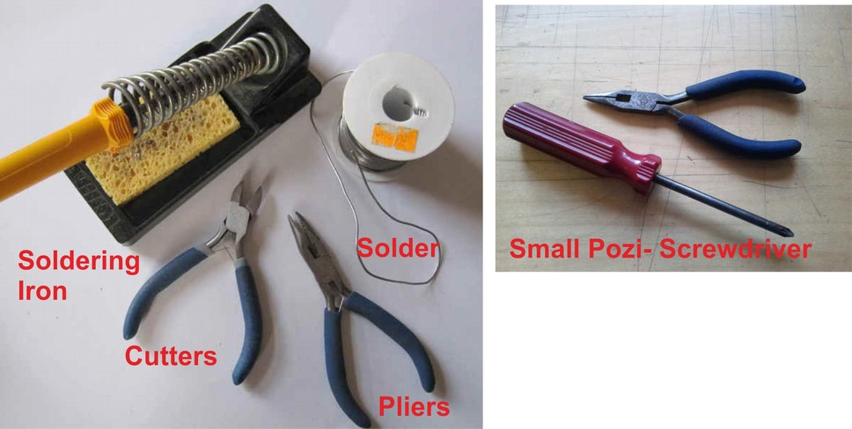

PCB Instructions:
Step: 1 | Solder resistors
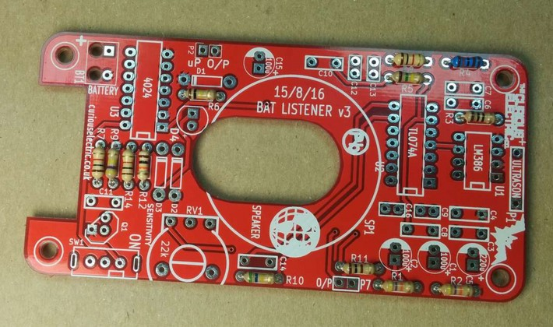  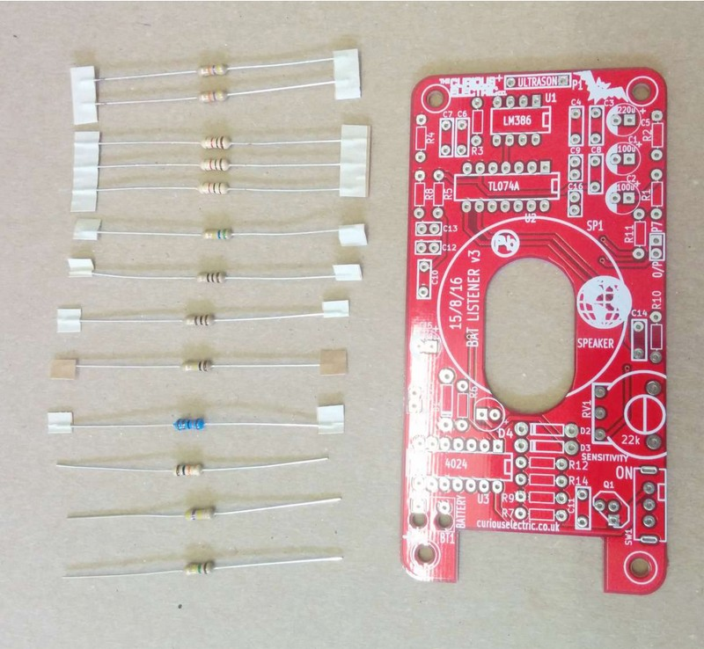 |  | Insert and solder the resistors.  Polarity does not matter for resistors.  Ensure they are soldered flat close to the PCB.  Note: Some resistors are blue – check the colour codes at the end of these instructions.  Use a multimeter or colour code chart to ensure correct resistor values.
  Value | Ref | Colour
  47k | R1, R2 | Yellow, Violet, Orange, Gold
  10 | R3 | Brown, Black, Black, Gold
  1.3k | R4 | Brown, Orange, Black, Brown, Brown
  150k | R5 | Brown, Green, Yellow, Gold
  10k | R6, R12 | Brown, Black, Orange, Gold
  1k | R7, R8, R14 | Brown, Black, Red, Gold
  470k | R9 | Yellow, Violet, Yellow, gold
  560k | R10 | Green, Blue, Yellow, Gold
  100 | R11, R13 | Brown, Black, Brown, Gold

Step: 2 | Solder capacitors
First solder the non-polarised capacitors.  Orientation of these does not matter:  Note: You may need a magnifying glass for reading the text on these capacitors.  Next solder the polarised capacitors. Ensure correct orientation of these components.  The negative lead is marked with a white strip. The positive lead is slightly longer than the negative. Align the positive lead with the + sign and the negative lead with the white PCB marking. |  | 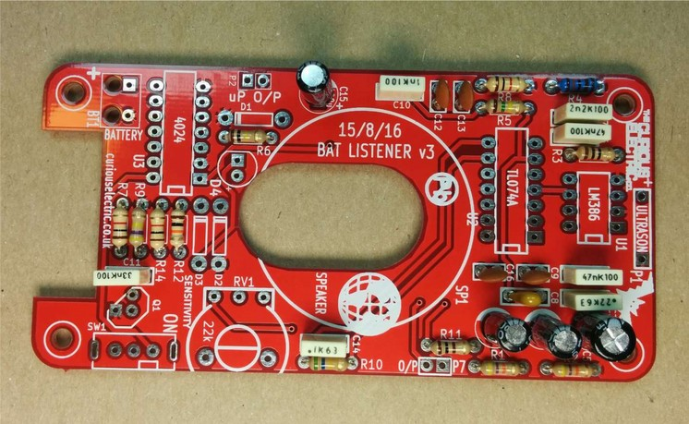  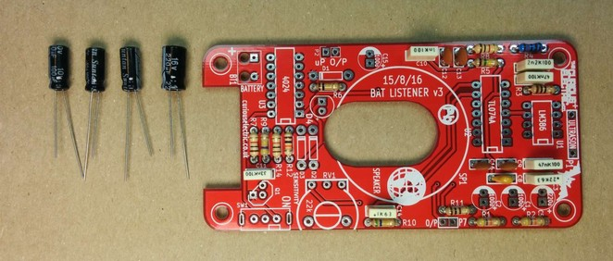  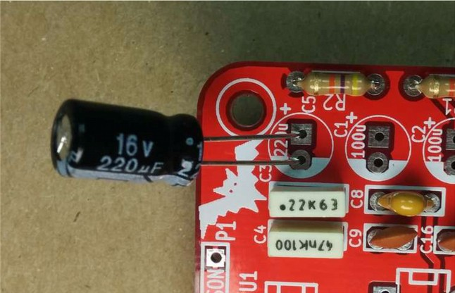  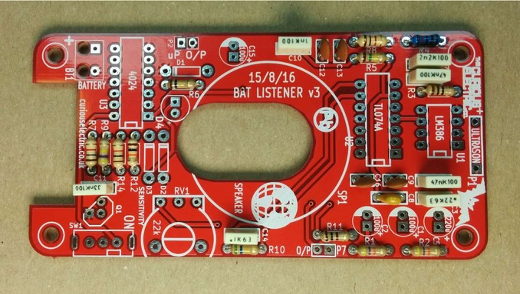  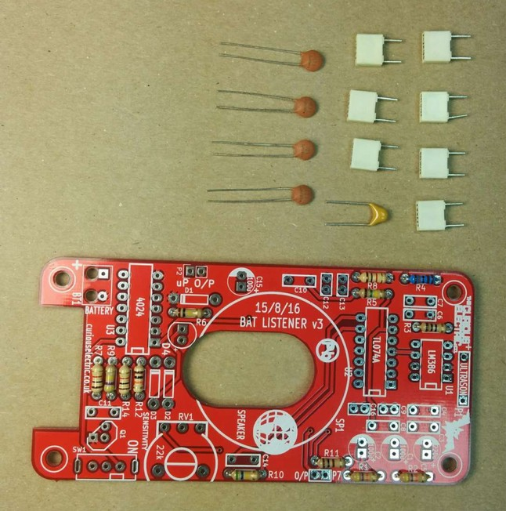
  Value | Ref | Marking
  220nf | C3 | ‘224’ (brown blob)
  47nf | C4, C6 | 47nK100 (cream box)
  2.2nf | C7 | ‘222’ (brown blob)
  1.5nf | C8 | 152 (brown blob)
  100pf | C9, C16 | 101 (brown disk)
  1nf | C10 | 1nK100 (cream box)
  33nf | C11, C17 | ‘333’ (brown blob)
  470pf | C12,C13 | 471 (brown disk)
  100nf | C14 | ‘104’ (brown blob)
  Value | Ref | Marking
  100uf Capacitor | C1, C2, C15 | 10V 100uf
  220uf Capacitor | C5 | 16V 220uf

Step: 3 | Solder diodes
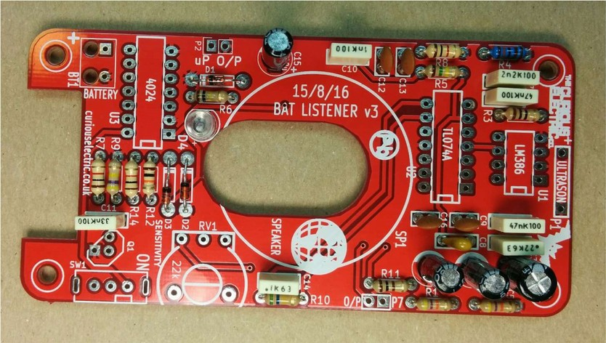  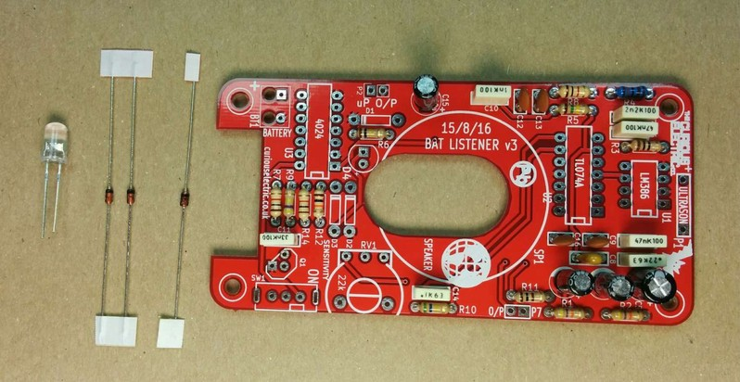 |  | There are 4 diodes to solder.  Ensure correct orientation for these components.  First solder the LED into D4.  The long lead is positive, so place that into the hole marked +. The negative side is slightly flat.  Then solder the 5.1 V zener diode into D1. This diode is on it’s own and has very tiny marking of “5V1”. Ensure the black band aligns with the white band marked on the PCB.  Then solder the remaining 2 diodes into D2 and D3. These have tiny markings saying “4148”. Ensure the black band aligns with the white band marked on the PCB.

Step: 4 | Solder transistor
There is just one transistor to solder, Q1, BC337.  Ensure the flat side of the transistor aligns with the PCB markings. |  | 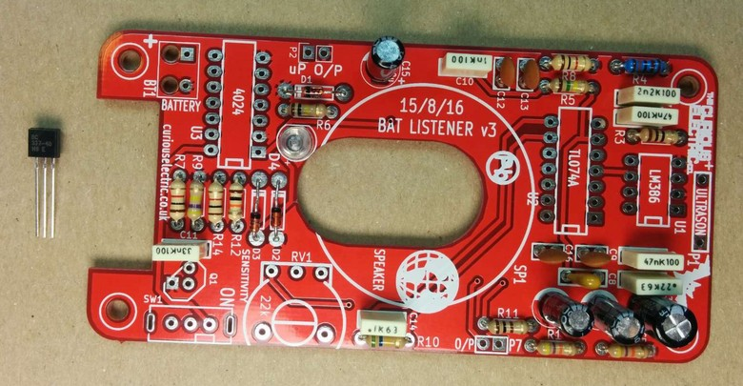  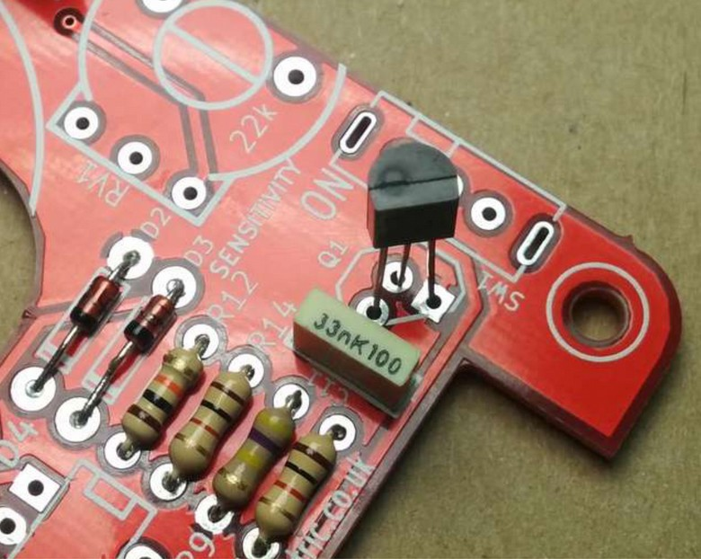

Step: 5 | Solder IC holders
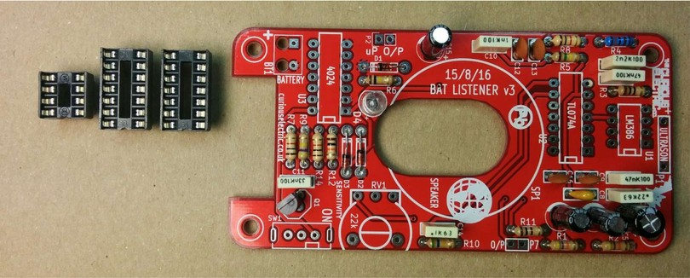  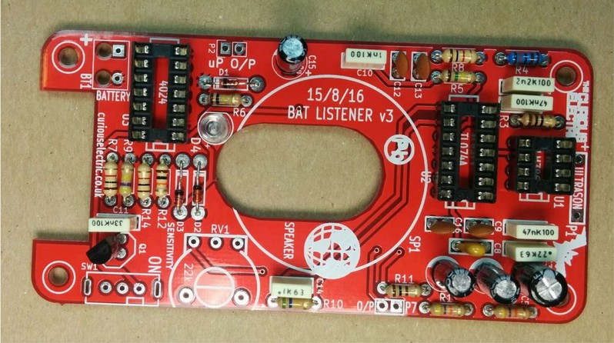 |  | There are two 14 pin IC holders and one 8 pin IC holder. These fit into the areas marked U1, U2 and U3.  Ensure correct orientation!  Ensure the notch on the holder aligns with the notch shown on the PCB.

Step: 6 | Solder Switch and Potentiometer
The switch fits into the holes marked SW1. The switch knob goes off the PCB.  Solder all metal tabs.  The potentiometer fits into the holes marked RV1. There are 5 pins to align and the pins might need slightly moving to ensure they align correctly.  Solder all metal tabs. |  | 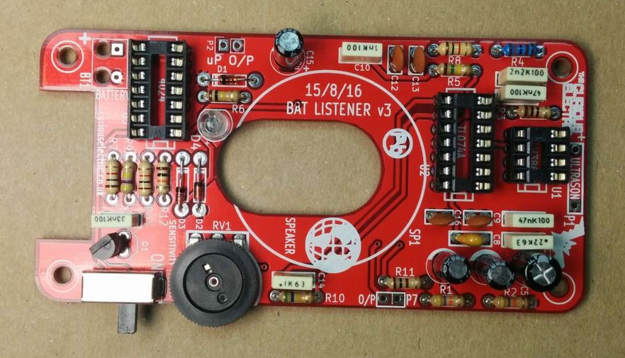  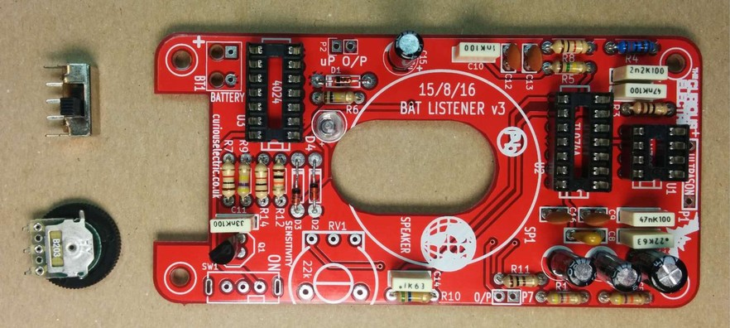
Step: 7 | Solder the ultrasonic receiver
The ultrasonic receiver has two pins, one is attached to the metal case of the unit, the other has a small ring around it.  The pin with the small ring around it is the +ve connection and this pin fits in the hole with the + symbol. The ground fits next to the indicator P1.  Carefully bend the legs to 90 degrees to the receiver is facing away from the PCB. |  | 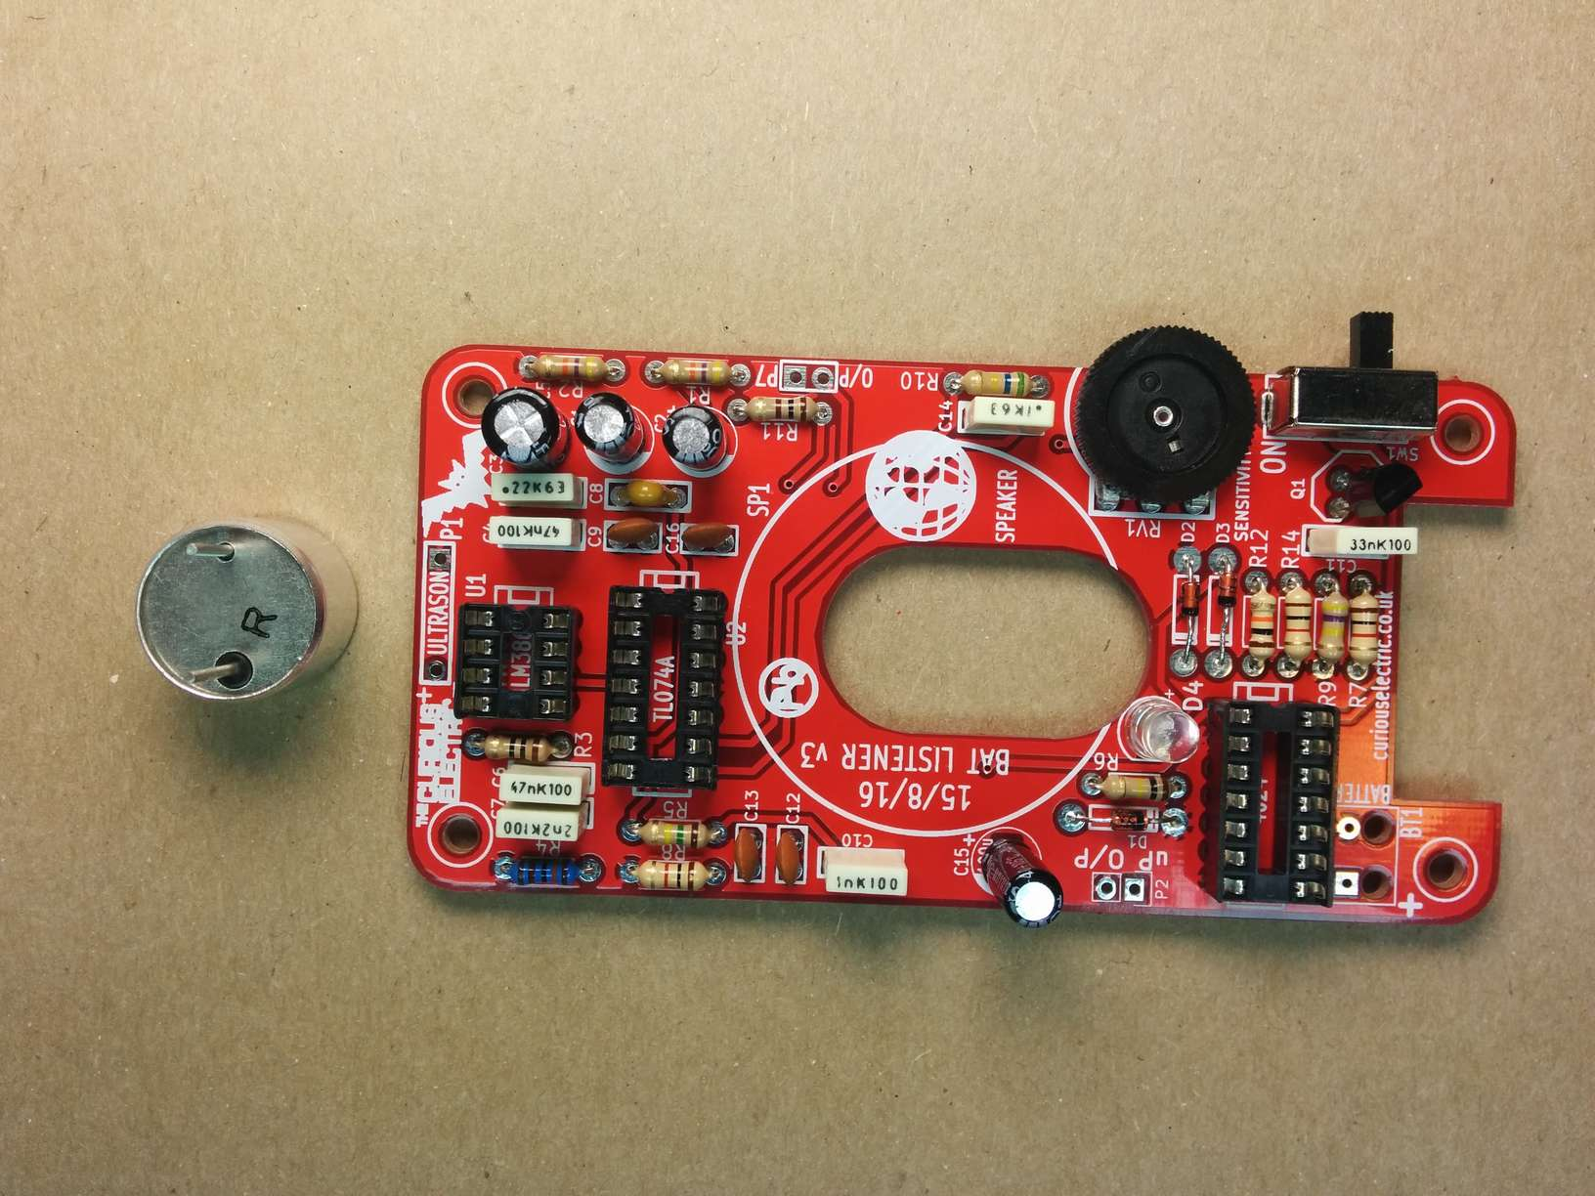

Step: 8 | Solder the headphone socket
The 3.5mm headphone jack socket is soldered on the back of the PCB. This must be soldered before the speaker.  Insert from the underside into ‘J1’ and solder from the top side of the PCB. |  | 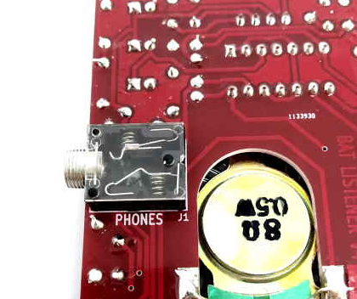

Step: 9 | Solder Speaker
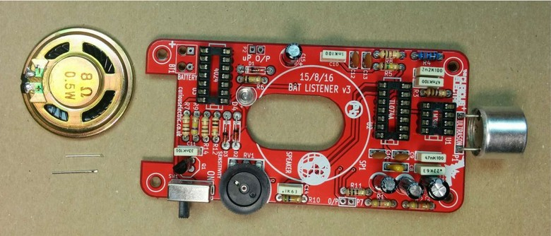  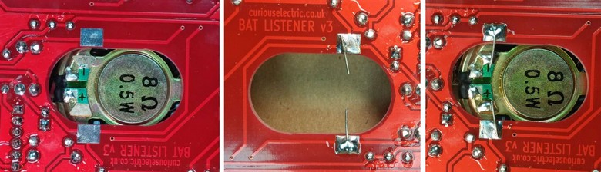  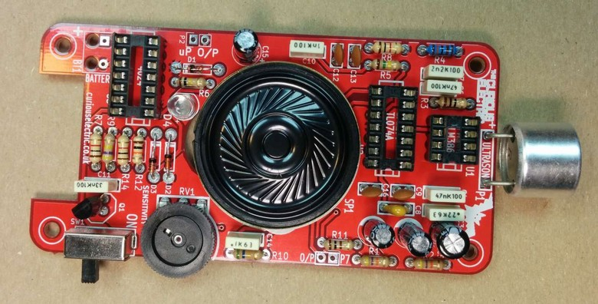 |  | The speaker has a slightly unusual mounting method.  The speaker base fits through the large hole in the PCB and the speaker tabs align with the PCB tabs.  Use an off-cut of resistor lead and solder two small leads from the PCB (as shown). Carefully bend the legs to 90 degrees before soldering in position facing away from the PCB.  Then put the speaker in place and solder the small wires to the speaker.  This method holds the speaker in place, as well as being the electrical connection.

Step: 10 | Solder PP3 battery connector
Nearly there!  The PP3 battery clip as two wires: one positive (red) and one negative (black).  I usually put a knot in the cable for strain relief.  The cables then go through the larger holes from the underside and are fed back into the solder pads.  The red cable goes through the hole to the pad marked “+”. |  | 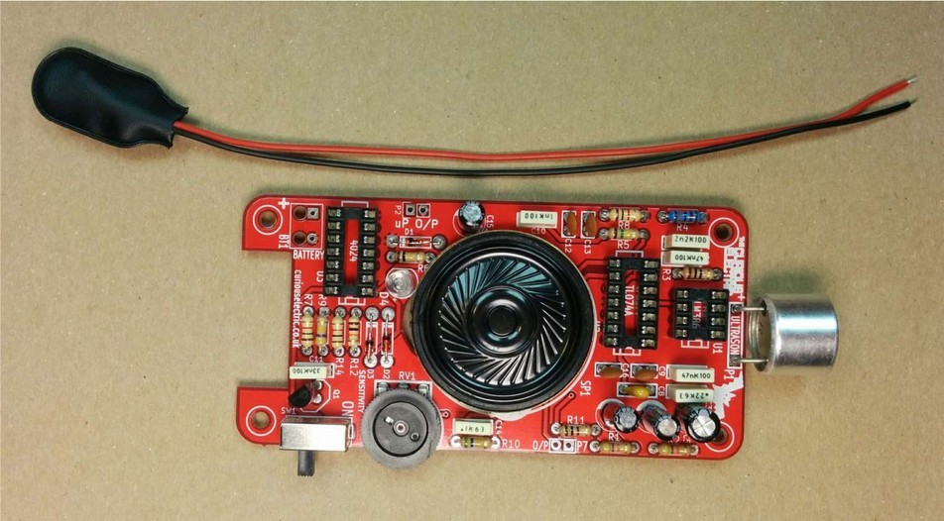  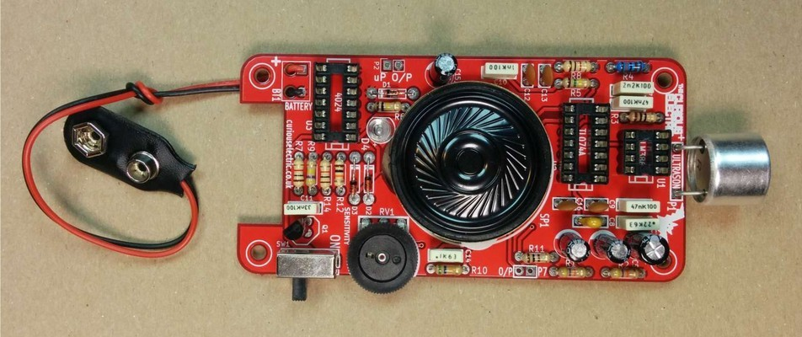  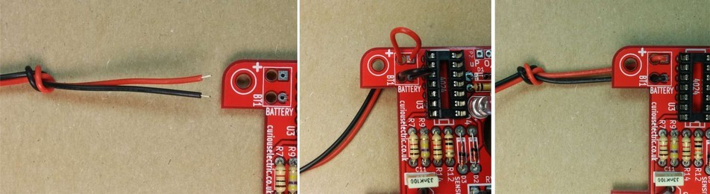

Step: 11 | Insert ICs
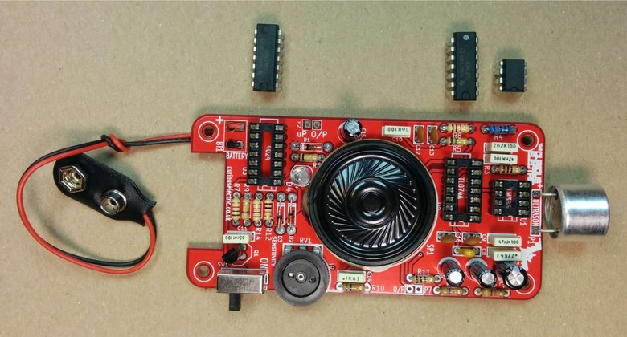 |  | Now we need to insert the ICs into their holders.  Ensure the notches align with the notches on the IC holders and the PCB.  U1 is the LM386 (8 pin)  U2 is the TL074 (14 pin)  U3 is the 4024 (14 pin)

Step: 12 | Insert battery and test
Add a PP3 9V battery to the battery clip. Switch the unit on.  You may hear a squeal from the device. Adjust the potentiometer until you just do not hear any noise.  The red LED should also flash when the speaker clicks.  Use a reel of sticky tape to test. Slowly peel the tape off the reel and you should hear crackles from the speaker. This is picking up high frequency sound from the glue breaking. You can also test by pointing at a compact fluorescent light bulb. These switch at around 100 kHz and hence give off ultrasonic noise. |  | 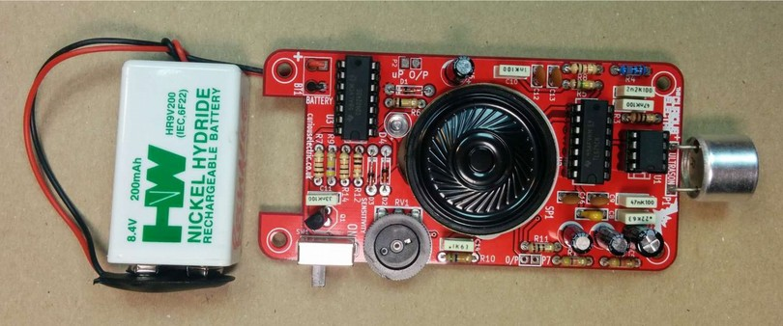

Step: 13 | PCB is finished!
Have a nice cup of tea.


Enclosure Instructions:
Step: 1 | Push out laser-cut parts and peel off protective layer
Sometimes not all the small laser-cut pieces have been removed. These can be pushed out using the point of a screwdriver. Only slight force should be required.  There is a protective film on one side of the laser cut parts. This can be removed by peeling off the film. |  | 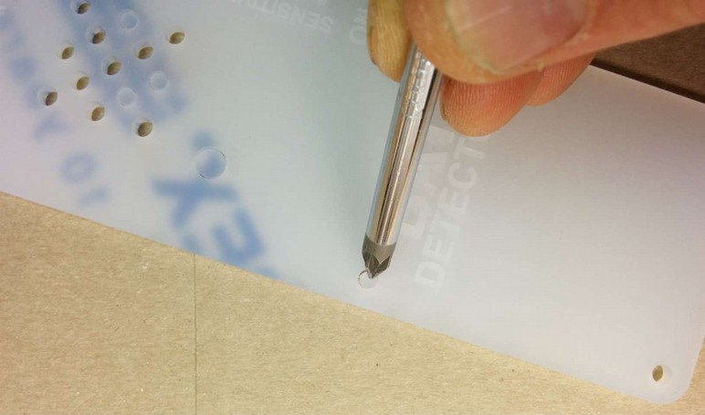  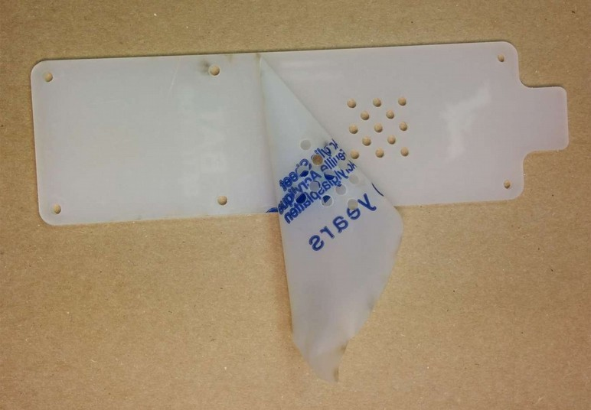

Step: 2 | Screw down the PCB
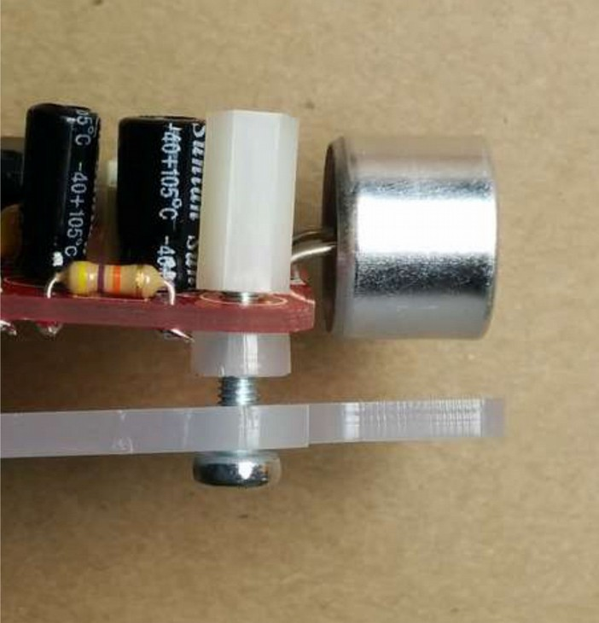  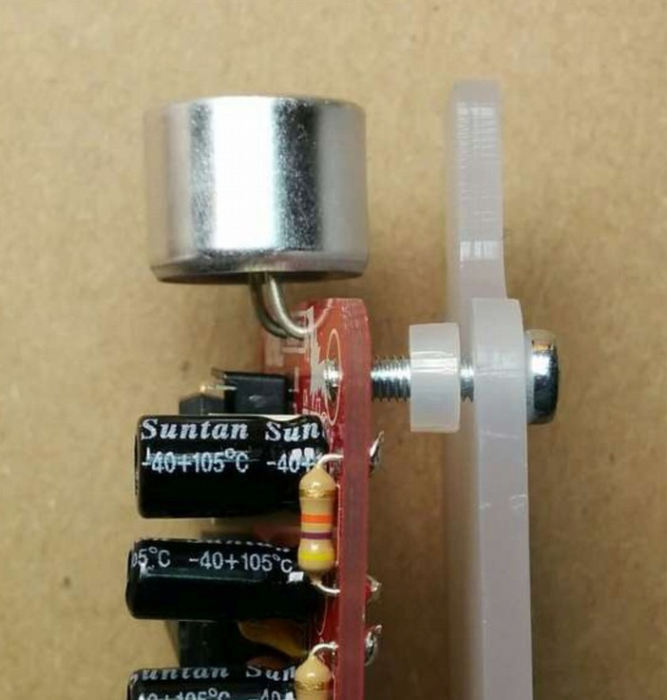  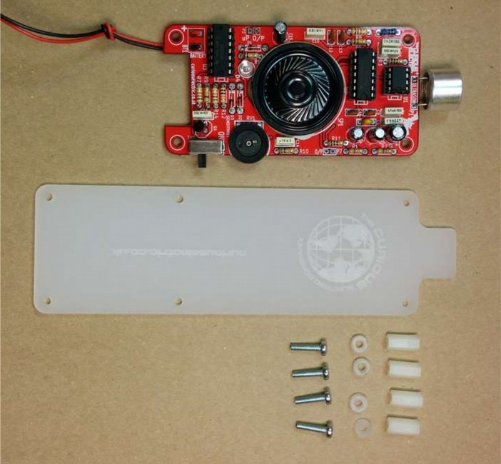  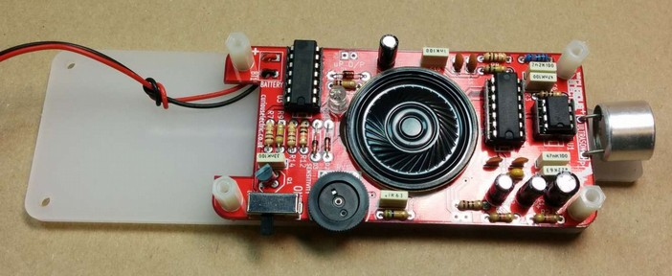 |  | The PCB is held onto the back plate using 4 of the M3 12mm screws and the hex spacers.  The back plate has the text facing to the back.  The screws fit through the back plate then through a small circular spacer ring and then through the PCB.  It is then held in place using the threaded hex spacer.  Do this for all four corners of the PCB.  Note: This photo does not show the headphone socket, which should align with the cut-out of the plastic base.

Step: 3 | Add end spacers
To hold the end spacers in place we again use the 12mm screws and 2 of the hex spacers.  Put them through the back plate and slightly screw the hex spacer onto the screw.  Do not fully tighten this, as it will need to spin to be adjusted in the next step. |  | 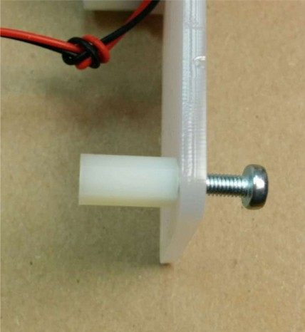  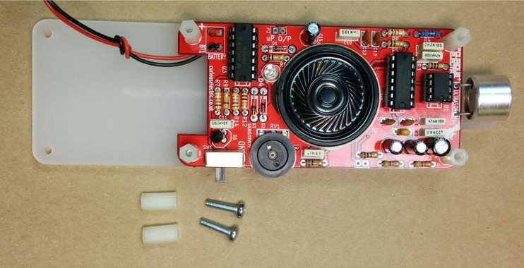

Step: 4 | Add battery holders
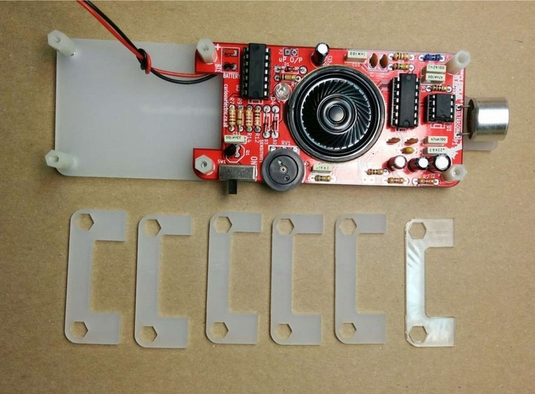  6  5  4  1  3  2  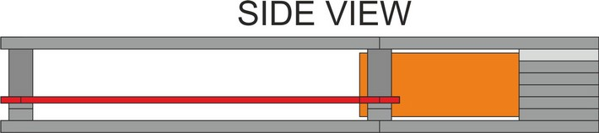  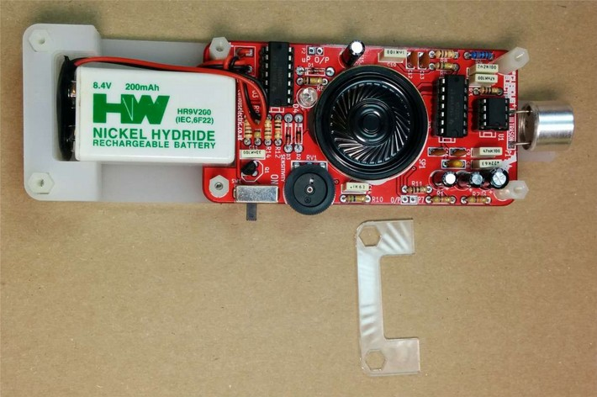  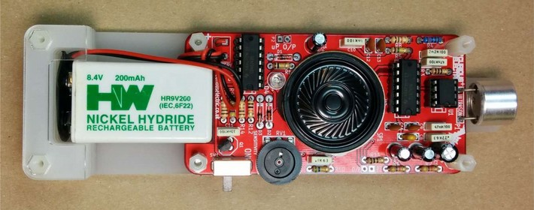 |  | The battery holders are 6 spacers which holds one end of the battery, with the other end being held the notch in the PCB.  There are three types of spacer:  1 x narrow 3mm spacer (in white frosted plastic, marked “1”)  4 x wide 3mm spacers (marked “2”, ”3”, ”4” & “5” ).  1 x narrow 2mm spacer in clear plastic (marked “6”).  These fit onto the hex spacers we just added.  First add the narrow 3mm piece(marked “1”).  Then the 4 wide 3mm pieces (marked “2”, ”3”, ”4” & “5”).  Put the battery into the enclosure. The PP3 battery clip fits within the wider section, with the cable able to come out of the side.  The final narrow 2mm spacer (marked “6”) is put on top.

Step: 5 | Fit top cover
The front cover is then put on with the text facing upwards.  Use the 4 x 6mm M3 machine screws to hold the front cover in place to the PCB holes and the final 2 x 12mm M3 machine screws to hold the end spacers in place.  These fasten into the threaded hex spacers.  Note: Some covers do not have the hole for the LED. The LED can be seen through the frosted plastic, so it is not needed. |  | 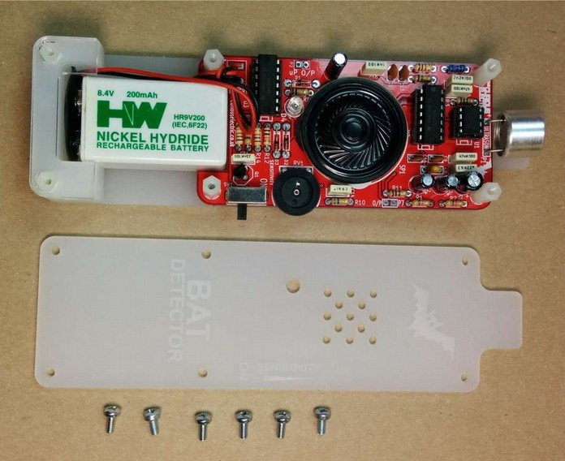  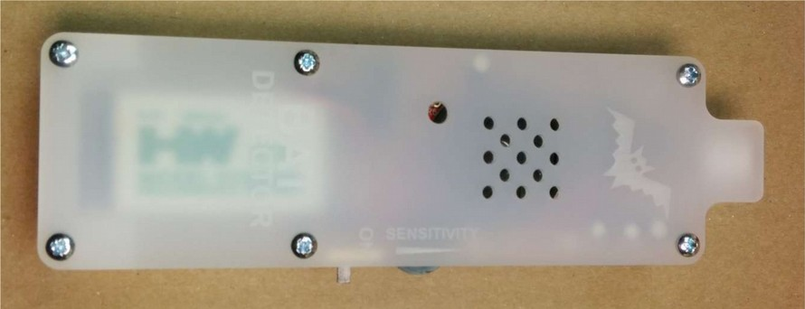

Step: 6 | Finished!
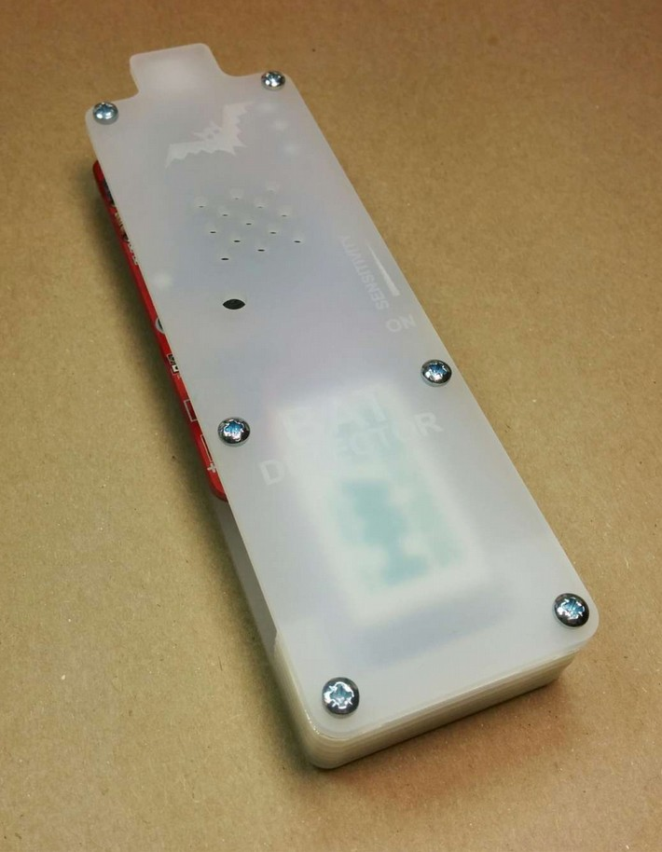 |  | That is the unit finished!  The on/off switch and the potentiometer are accessible via the side of the unit.  You now have your own bat detector.  There are many things you can investigate including:  Nature: monitor bats, mice and rats  Electrical: Check the sound from switching power supplies and fluorescent lights
Please note: This unit is NOT waterproof. Do NOT leave outside if it will get wet.
Contact details:
We would like you to be happy with this kit. If you are not happy for any reason then please contact us and we will help to sort it out.

Please email hello@curiouselectric.co.uk with any questions or comments.
Please tweet us at @curiouselectric

If any parts are missing from your kit then please email hello@curiouselectric.co.uk with details and, if possible, when and where the kit was purchased.

More technical information can be found via www.curiouselectric.co.uk

This kit has been designed and produced by:
The Curious Electric Company
hello@curiouselectric.co.uk
www.curiouselectric.co.uk
Unit 23, Block D, Hartley Business Centre, Haydn Rd, Nottingham, NG5 1DG, UK

History
This kit is based upon a circuit originally published by Elektor Electronics: http://www.elektor.com/magazines/2011/november/simple-bat-detector.1971945.lynkx

and was originally developed as a workshop for Nottingham Hackspace: www.nottinghack.co.uk
Circuit Schematic

Resistor Colour Codes
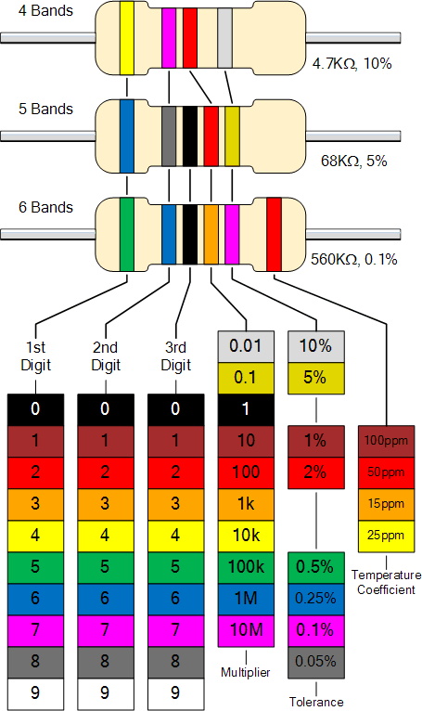
0

1

2

3

4

5

6

7

8

9

